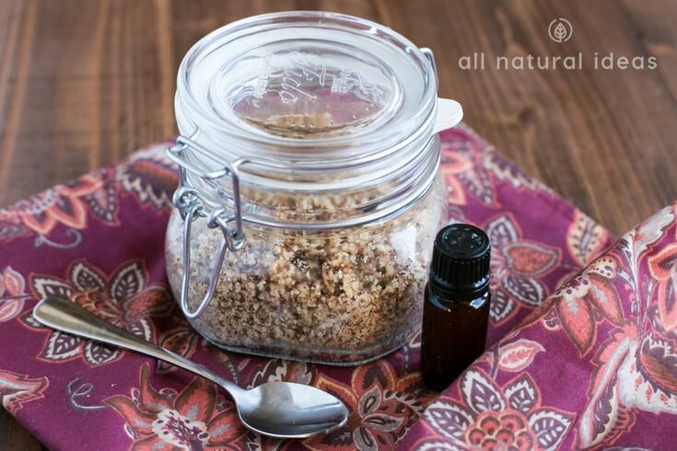
ALMOND FACIAL SCRUB
Use this once a day instead of an expensive, chemical ridden cleanser. The oils can be change up to include one that suits your needs. For example, tea tree oil would be good for skin prone to break outs.
INGREDIENTS
1 cup ground almonds
1 – 3 teaspoons oil of choice (Either olive, jojoba, sweet almond, etc)
1 – 2 teaspoons witch hazel
Essential oil (a few drops if desired)
METHOD
- Mix the ground almonds, oil and witch hazel together. Add more oil to get the consistency of a thick paste.
- Stir in essential oil of choice if desired.
- Put it into a container with a lid on it.
- When you use this to clean your face, take a small amount and add water to it in order to make a spreadable paste on your face. Scrub away for a few minutes, wash off to reveal glowing smooth skin!

